UNIT-3

Satellite Networks

Satellite Communications Characteristics
Satellite communications typically comprise two main units, the satellite itself and the Earth Station (ES). The satellite, which is also known as the space segment of the system, essentially acts as a wireless repeater that picks up uplink signals (signals from the ES to the satellite) from an ES and, after amplification, transmits them on the downlink (from the satellite to the ES) to, possibly more than one, other ESs. Due to this functionality, satellites are also known as bent-pipes. The uplink occupies a different frequency band than that of the downlink. Furthermore, there may exist more than one uplink channel. Thus, satellites typically contain many transponders, each of which contains receiver antennae and circuitry in order to listen to more than one uplink channel at the same time. Using the above scheme, communications between two or more ESs that are substantially far away from one another is established over ES-satellite links. The uplink is a highly directional, point-to-point link using a dish antenna at the ground station. The downlink can cover a wide area or alternatively focus its transmission on a small region which will reduce the size and cost of ESs. Some satellites can also dynamically redirect their focused transmissions and thus alter their coverage area. Moreover, as seen in later sections, satellites exist that employ the functionality that enables them to communicate directly with one another either for control or data message exchanges.
Satellite communication systems have a number of characteristics that differentiate them both from wired and other kinds of wireless links. These characteristics are briefly summarized below:
Wide coverage. Due to the high altitudes used by satellites, their transmissions can be picked up from a wide area of the Earth’s surface. The area of coverage of a satellite is known as its footprint.
†
Noise. It is known that the strength of a radio signal reduces in proportion to the square of the distance between the transmitter and the receiver. Thus, the large distances between the ESs and the satellite makes the received signal very weak, typically in the order of a few hundred of picowatts). This problem is typically combated by employing FEC and ARQ techniques.
†
Broadcast capability. As mentioned above, satellites are inherently broadcast devices. This means that a transmission can be picked up by an arbitrary large number of ESs within the satellite’s footprint without an increase in either the cost or complexity of the system.
†
Long transmission delays. Due to the high altitude of satellite orbits, the time required for a transmission to reach its destination is substantially more than that in other communication systems. Such propagation delays, which can be between 250 and 300 ms can cause problems in the design of satellite communication systems. An example of this situation is the inefficiency of using the CSMA/CD MAC protocol in satellite systems: It is known that in order for the carrier sensing mechanism of a CSMA protocol to perform satisfac- torily, the propagation delay t must be comparable to the frame transmission time t (in IEEE 802.3 LAN t 2t). Since it is not possible for satellite frame transmissions to last at least 500–600 ms each, it is obvious than in satellite systems t ! t, thus CSMA applica- tion will be inefficient. In most satellite systems, the access method used is FDMA- or TDMA-based.
¼
†
Security. As in all kinds of wireless communication systems, security is also a major concern in satellite systems.
†
Transmission costs independent of distance. In satellite systems, the cost of a message transmission is fixed and does not depend on the distance traveled.
†

Spectrum Issues
As in other wireless communication systems, satellite systems are also subject to interna- tional agreements that regulate frequency use. Such agreements also regulate the use of the various orbits, which is described in the next section. Figure shows the three bands that are commonly used. It can also be seen from this figure that different frequencies are used for the uplink and downlink channels. The ‘C’ bands were the first to be used for satellite traffic. The frequency range of this band leads to dish diameters of 2–3 m. However, the ‘C’ band is overcrowded nowadays due to the fact that it is also being used by terrestrial microwave links. As a result, the trend is towards use of the higher-
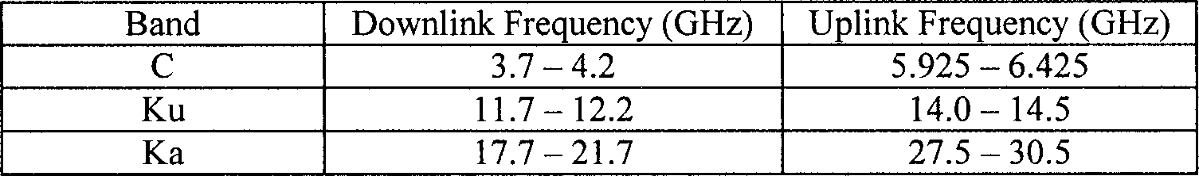

Figure 7.1 The main frequency bands for satellite systems
frequency Ku and Ka bands. The Ku band is typically used for broadcasting and Internet connections and enables antenna diameters as low as 0.5 m. This band typically suffers less interference than the ‘C’ band, however, its higher frequency makes it susceptible to interference. Specifically, this band is subject to interference from rain, however, this can be combated by using a large number of widely separated interconnected ESs. As storms appear over relatively small geographical areas, they are likely to cause interference only to a small number of ESs and the system will be able to adapt by switching between ESs. The above problem also concerns the Ka band, which also has a disadvantage in terms of cost, since the equipment needed to operate at this band is more expensive than that for the other bands. Plans to use frequency bands higher than Ka, such as the V band (40–75 GHz) also exist. These offer the advantages of higher bandwidths and smaller antenna size, however, the technologies needed to use these bands are still under development.
From Figure 7.1, it can be seen that in all bands the lower part is the one that serves downlink traffic while the upper part serves uplink traffic. This is because higher frequen- cies suffer greater attenuation than lower ones and consequently demand increased trans- mission power to compensate for the loss. By using low frequency channels for the downlink, satellites can operate at lower power levels and thus preserve energy. On the other hand, ground stations are not subject to power limitations and thus use the higher parts of the bands.

Applications of Satellite Communications
There are a number of applications where satellite communication systems are involved. An indicative list is briefly outlined below.
Voice telephony. Satellites are a candidate system for interconnecting the telephone networks of different countries and continents. Although the alternative of cables also exists, satellite use for interconnecting transoceanic points has sometimes been preferred rather than installing submarine cables.
†
Cellular systems. Satellite coverage can be overlaid over cellular networks to provide support in cases of overload. When cells in the cellular network experience overload, the satellite can use a number of its channels to serve the increased traffic in the cell.
†
Wordwide coverage systems. Satellite systems can provide connectivity even to places where no infrastructure exists, such as deserts, oceans, unpopulated areas, etc.
†
Connectivity for aircraft passengers. This is a service that is provided by geostationary satellites. Aircraft can be equipped with transceivers that can use such satellites to provide connectivity to passengers while airborne.
†
Global Positioning Systems (GPS). The well-known GPS system offers the ability to determine the exact coordinates of the GPS receiver. This is achieved with the help of multiple satellites through triangulation.
†
Internet access. Satellite communication systems possess a number of characteristics that enable them to effectively provide efficient Internet access to globally scattered users. Such characteristics are the broadcast capability of satellite systems, their potentially worldwide coverage independent of terrestrial infrastructure and support for mobility. This issue is described in a later section.
†

Satellite Systems
Satellite communication systems comprise two main parts: the ground segment and the space segment. The ground segment consists of gateway stations, a network control center (NCC) and operation control centers (OCCs). Gateways interface the satellite system to terrestrial networks, perform protocol translation, etc. NCCs and OCCs deal with network management and control of satellite orbits. The space segment comprises the satellites themselves, which are often classified by the orbit they use. Thus, satellite orbits are an essential characteristic of a satellite communication system. They are characterized by the following properties:
Apogee: the orbit’s farthest point from the Earth.
†
Perigee: the orbit’s closest point to the Earth. This has to be significantly outside the Earth’s atmosphere in order to avoid severe friction.
†
Orbital period: This is the time it takes to go around the Earth once when in this orbit and is determined by the apogee and perigee.
†
Inclination: This stands for the angle between the orbital plane and the equatorial plane of Earth.
†
Circular orbits can be categorized in ascending order into low, middle and geosynchro- nous. These are shown schematically in Figure . A discussion on the characteristics of the various orbit categories is given below followed by a discussion on the characteristics of systems that employ elliptical orbits.
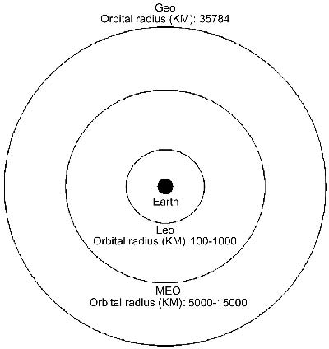

Figure: Low, middle and geosynchronous circular earth orbits

Low Earth Orbit (LEO)
LEO orbits are those that lie in the area between 100 and 1000 km above the Earth’s surface. The small radius of a LEO orbit gives it a small period of rotation T (typically between 90 and 120 min), which of course translates into a high orbiting speed (high angular velocity). The main characteristics of LEO orbits are the following:
Low deployment costs. Lower orbits are easier to reach by rocket systems. This translates into reduced cost for satellite deployment.
†
Very short propagation delays. Due to their low distance from the Earth’s surface, LEO systems exhibit very short propagation delays. This is a very useful property that simplifies the development of satellite communication systems, especially voice-related ones. Typi- cal propagation delays for LEO are between 20 and 25 ms, which are comparable to that of a terrestrial link.
†
Very small path loss. As we have seen, the received signal strength at distance r follows a kr^{2n} characteristic. This of course means that lower orbits are characterized by a smaller path loss and thus a smaller BER. Thus, LEO-based systems have low power require- ments. Furthermore, for a given transmission power, LEO systems can receive the signal more easily than higher-orbit systems, a fact that lowers the complexity of terminals. This lower complexity allows for portable terminals.
†
Short lifetime. The Earth’s atmosphere extends to several thousands of kilometers above its surface and becomes thinner with increasing height. At the altitudes of LEO systems,
†
friction with atmospheric molecules is more intense than in higher orbits. This fact causes LEO satellites to quickly lose height and eventually fall back to Earth. Some satellites contain small boosters that regularly re-adjust their height in order to compensate for the loss. However, these boosters require fuel and cannot operate using solar power. Thus, when the satellite runs out of fuel the problem still exists. Of course, LEO satellites could be brought back to proper orbit by a space shuttle, as happens in the case of the Hubble telescope. However, this approach is more costly than deploying a new LEO satellite and is thus not followed. Consequently, LEO systems have a small lifetime and must be replaced every few years.
Small coverage. The low height of a LEO satellite means that it has a decreased footprint. This fact is a disadvantage of LEO systems due to the fact that many satellites are required for worldwide coverage (e.g. the Iridium project that is covered later called for a constella- tion of 66 LEO satellites). As a consequence, both the complexity and cost of a LEO system to cover the entire Earth is increased.
†
Small Line of Site (LOS) times. LEO systems are characterized by angular orbiting speeds. This is problematic from the point of view of the time the satellite remains visible from a given location on the Earth’s surface. For LEO systems this time is very small. This means that terminals will need to possess steerable antennae in order to track the satellites as they move. Furthermore, the high angular speed raises the need for efficiently combating large Doppler shifts. These facts of course raise terminal complexity.
†

Medium Earth Orbit (MEO)
MEO orbits are those that lie in the area between 5000 and 15,000 km above the Earth’s surface. These orbits are higher than those of LEO systems, thus the orbital period T also increases (typical values of T are several hours). At such distances, the characteristics considered as advantages of LEO systems, fade to become disadvantages for MEO systems. Similarly, the characteristics considered as disadvantages of LEO systems, become advantages for MEO systems. Some of them are briefly summarized below:
Moderate propagation delay. Although not much higher than that of LEO systems, the propagation delay in MEO systems is higher.
†
Greater lifetime. The atmosphere is thinner at higher orbits. Thus, MEO systems experi- ence lower friction with atmospheric molecules, a fact that translates into higher lifetimes. Increased coverage. The relatively high orbits of MEO systems give them an increased footprint. Compared with lower orbits, fewer satellites are needed to achieve worldwide coverage. A typical number is around ten. However, the exact number depends on the orbit radius.
†
†
Theoretically, MEO satellites can be deployed as high as 35,000 km or more. However, few MEO satellites use orbits above 10,000 km. This is due to the fact that at distances greater than this, deployment costs and propagation delay become significant without additional advantages. The most well-known system that uses MEO orbits is the Global Positioning System (GPS).

Geosynchronous Earth Orbit (GEO)
The Geosynchronous Earth Orbit (GEO) was discovered by Arthur Clark in his work [1]. If a satellite is placed at approximately 36,000 km above the Earth’s surface, then its angular velocity will be the same as that of the Earth.
A special case of GEO is the Geostationary Earth Orbit. In this, the satellite rotates at an inclination of 908, which means that it remains in the same spot above the Equator. In such a case the satellite will appear to remain fixed at the same position in the sky. This is very useful for communications systems since ESs antennae do not have to track the satellite as it moves but rather remain focused on a specific point.
Contrary to common belief, the Geosynchronous Earth Orbit has a period of 23 h and 56 min, not 24 h. This is because Earth makes a complete rotation around its axis in 23 h and 56 min. On the other hand, 24 h is the duration of the so-called solar day, which stands for the duration of a complete rotation of the Earth relative to the Sun. This difference of about 4 min stems from the Earth’s motion around the Sun. Due to this motion, Earth has to rotate slightly more than 3608 so that a given place on its surface points exactly towards the Sun. Consequently GEO satellites have an orbital period of 23 h and 56 min to match the angular speed of the Earth.
The main characteristics of GEO are the following:
No atmospheric friction. At such a high altitude, atmospheric friction is nearly nonexis- tent. As a result GEO satellites remain in orbit for a very long time.
†
Wide coverage. Due to their high altitude, GEO systems exhibit a wide coverage. By using three GEO satellites spaced 1208 from one another, almost worldwide coverage can be achieved with obvious advantages for multicasting applications.
†
High deployment costs. Due to the high altitude of GEO systems, the construction of rockets in order to deploy or reach the satellite for repair is high.
†
High propagation delay. The high altitude of the geostationary orbit incurs a significant propagation delay. This causes problems for applications that require low delays, such as voice-related and interactive applications. Typical values of this delay for GEO systems are between 250 and 280 ms.
†
High path loss. The high altitude of the geostationary orbit also translates into increased path loss. This translates into a need for increased transmission power and antennae sizes, which of course makes the construction of portable, low-cost mobile devices that commu- nicate with GEO satellites difficult. The same problem applies to satellites, which also need to employ large antennae and powerful transmitters.
†
Geostationary satellites also have the following properties:
Static position. Geostationary satellites appear to remain fixed at the same position in the sky, thus ESs only need to point their antennas at the satellite position once and leave them there.
†
Reduced coverage at high latitudes. Geostationary satellites rotate above the Equator. This means that coverage at regions in the north and south is problematic due to the fact that a clear LOS must exist between the satellite and the ES. In regions of the Earth in the north and south the satellite will appear low in the horizon and LOS may be obstructed by buildings, hills, etc. This is shown schematically in Figure . Furthermore, the received signal power at these areas will be less, as for such latitudes it will have to travel through a
†
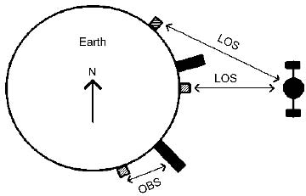

Figure Line of Site (LOS) and Obstructed Line of Sight (OBS) situations at different latitudes for a geostationary satellite

longer path in the atmosphere. This is shown in Figure 7.4. Thus, the dish size of ESs at such latitudes has to increase in order to compensate for the weakening of the signal.
The geosynchronous orbit above the equator seems to be a valuable resource. As in the general case of GEOS, satellites at this orbit must be placed apart by at least 28, meaning that there is room only for 180 geostationary satellites. As with frequencies, orbits are also handled by the ITU, which originally used a first-come first-served approach to assign geostationary orbit ‘slots’ to interested countries. As a result, such slots were mostly awarded to technologically advanced countries, a fact that irritated equatorial countries. Thus, ITU decided to allocate to these countries slots of their own. However, since few could actually use them, these slots remained unused until ITU stated that slot owners must either launch a satellite or give up their rights on the slot.
†

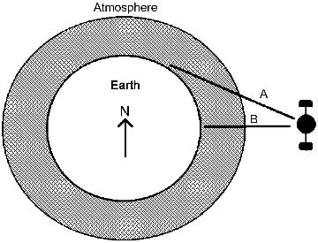

Figure : In situation A the path traveled through the atmosphere is longer than for B
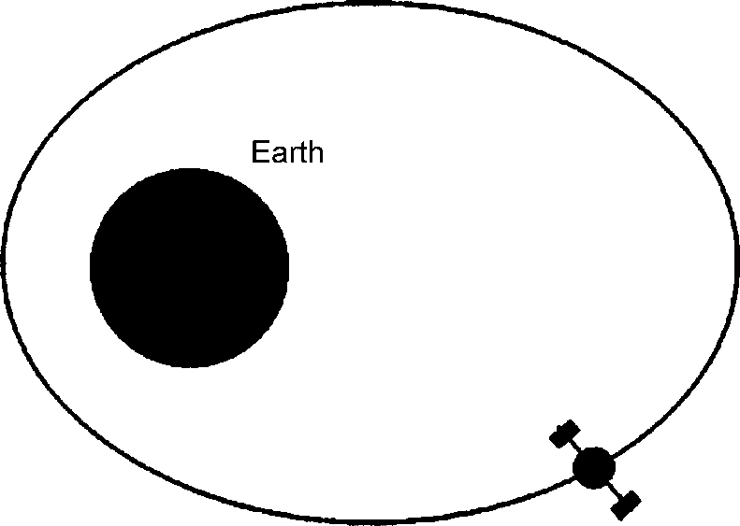

Figure : An elliptical-orbit satellite

Elliptical Orbits
Apart from the LEO, MEO and geostationary orbits, which are all very close to circular, there are satellites that employ elliptical orbits. Such an orbit is shown in Figure 7.5. The elliptical nature of the orbit results in a variation of both the altitude and the speed of the satellite. Near the perigee, the satellite altitude is much lower than that near the apogee. The opposite applies for the orbital speed. Near the perigee the speed is much higher than that near the apogee. As a result, from the point of view of an observer on the surface of the Earth, an elliptical-orbit satellite remails visible for only a small period of time near the perigee but for a long period of time near the apogee.
Elliptical-orbit satellites combine the low propagation delay property of LEO systems and the stability of geostationary systems. Thus, such a satellite has the properties of a LEO system near the perigee of its orbit (low delay, low LOS times) and the properties of a geo stiationary system near the apogee (high LOS times, high propagation delays). Elliptical-orbit satellites are obviously easier to access near their apogee because their high LOS times and low speeds permits ESs to track them without having to perform very frequent antenna readjstments. Thus, systems that employ such orbits have found use in systems that provide high LOS times for regions of the Earth far in the north or south. Since such areas cannot be effectively serviced by geostationary satellites as they orbit above the equator, elliptical orbits can provide high LOS times for such areas. This approach was followed by the former USSR in the Molniya satellites; since most of USSR is located far too north for geostationary satellite coverage, three elliptical-orbit satellites at an inclination of 63.48 have been used. The orbits were chosen in such a way so that at least one satellite covered the entire region of the country at any time instant. The parameters¹ of the Molniya system are depicted in Figure 7.6, along with those of other elliptical-orbit systems.

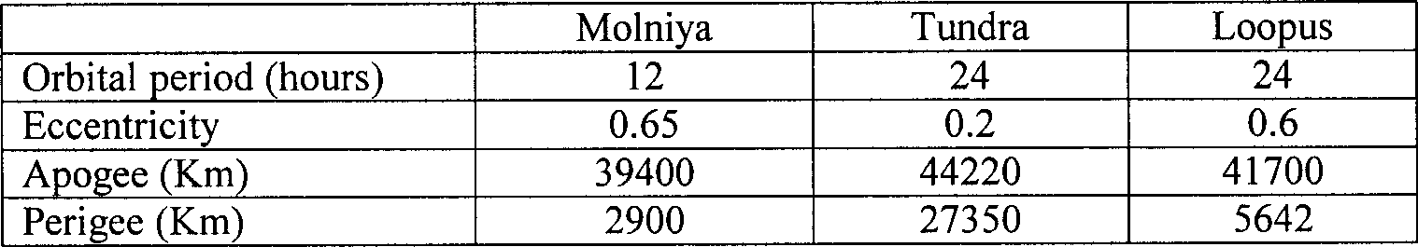

Figure : Parameters of elliptical-orbit satellite systems

VSAT Systems
As mentioned above, the design of ESs in satellite-based systems is quite complicated. This increases both construction and maintenance costs. An innovation in data commu- nication satellites was brought about by the development of highly directional antennae which can focus transmission on a certain area of the Earth’s surface. If such a directional antenna is integrated into the satellite, then ESs can afford to employ a smaller antenna in order to reduce their size and cost. This approach is known as Very Small Aperture Terminals (VSAT).
A VSAT system is typically organized into a star architecture, as shown in Figure. The system comprises the following elements:
A number of relatively small-sized terminals. The small size of VSAT terminals allows easy installation at user premises and even mobility. However, as the system uses a geostationary satellite, the VSAT antenna size depends on the latitude of the terminal. Furthermore, it depends on the frequency used, since higher frequencies typically demand a smaller antenna.
†
An ES acting as a hub. This ES has a very powerful antenna, employs routing capabilities and has a high-speed connection to a wired backbone in order to serve as a gateway to/ from the VSAT network.
†
A geostationary satellite equipped with a directional antenna. This satellite is used to connect the VSAT terminals to the hub.
†

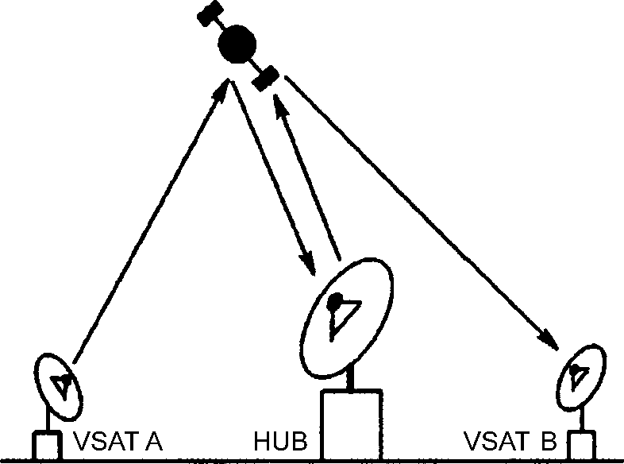

Figure: VSAT architecture
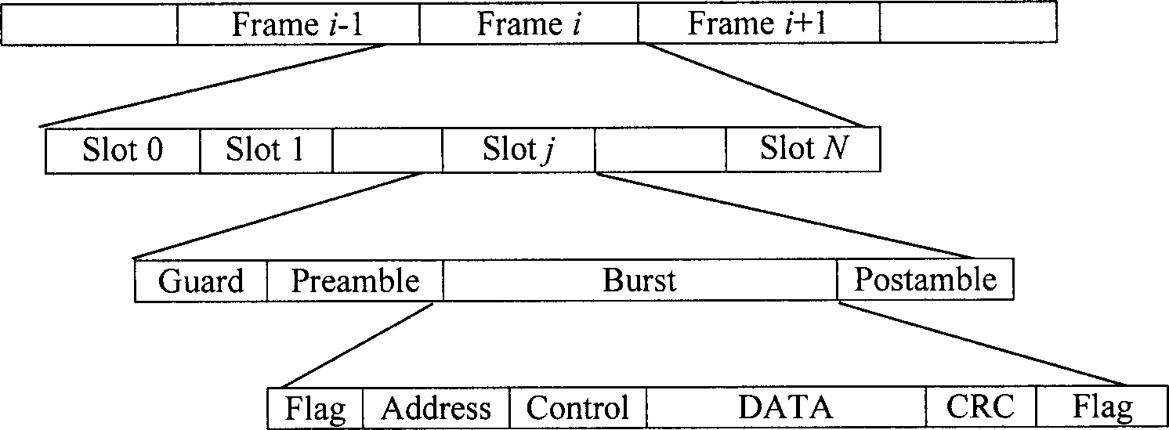

Figure: VSAT-to-hub channel structure

Using the architecture of Figure 7.7, the VSAT terminals transmit data to the satellite by using a random access technique. Most of the time this is ALOHA-based with typical examples being pure ALOHA, slotted ALOHA or an ALOHA/TDMA combination, like the dynamic TDMA schemes that were covered in Section 6.2. The organization of the VSAT to hub channel is shown in Figure. After receiving VSAT traffic, the satellite transmits it back to the hub. The hub performs collision checks and upon successful reception of a packet, uses the satellite to route the packet to the intended destination.
Contrary to traffic from the VSAT terminals to the hub, traffic in the opposite direction is delivered via a TDM scheme. This scheme is shown in Figure. It comprises a number of frames which in turn comprise slots that are used to transmit packets. As can be seen from the figure, every frame comprises a synchronization pattern which is used to keep the VSATs reliably synchronized. Every VSAT uses the address field to extract from the TDM scheme the packets which are destined for it and filter out all other packets. Of course, special addresses can be used in order to enable a message in the uplink to be broadcast to all VSATs or multicast to a specific group of VSATs. As far as network protocols are concerned, the most commonly used in VSAT systems is X.25.
VSAT systems are especially useful for interconnecting large numbers of users residing in remote areas. Furthermore, in some cases a VSAT system is likely to be more econom-

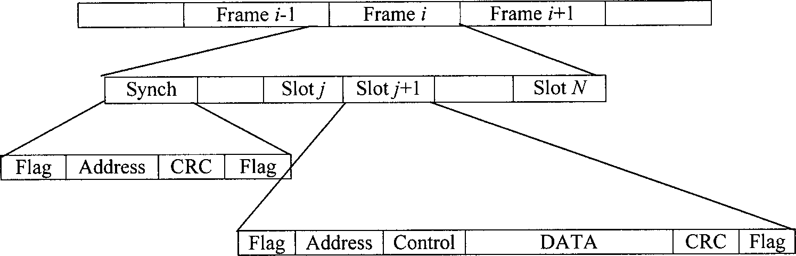

Figure : Hub-to-VSAT channel structure
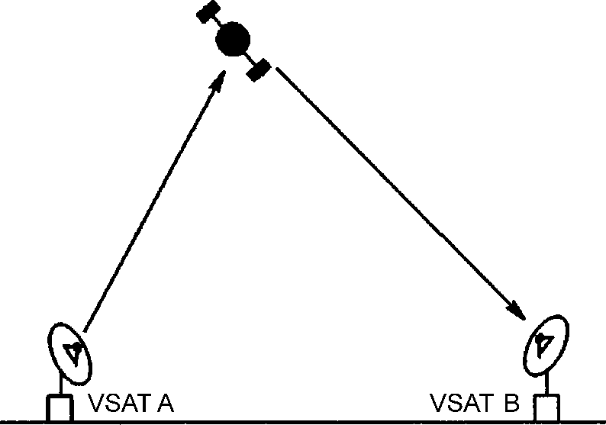

Figure: A VSAT communication system via an intelligent satellite

ical than a wired-based system. However, the main disadvantage of a VSAT-based system is that terminal traffic has to be relayed through the ES, a fact that results in a delay at least twice that of the propagation delay from a VSAT to the satellite. However, in recent years, technology has enabled incorporation of the functionality of the ES hub into the satellite. Thus, VSATs can now be connected directly via the intelligent satellite, as shown in Figure 7.10, with an obvious decrease in the propagation delay.

Examples of Satellite-based Mobile Telephony Systems
In the late 1980s, satellite systems appeared to be a promising approach for constructing telephony systems with worldwide coverage. At that time, conventional cellular telephony was not very widespread and its cost was relatively high. These facts made room for satellite-based systems. However, by the time satellite-based systems were ready for deployment, the market penetration of cellular telephony was so big that little space was left for satellite phones. However, satellite telephony is not completely without future or benefit: It is still an efficient way to link mobile users existing in regions of the world without communications infrastructure. Furthermore, it may be the only available mobile telephony system in many regions of the world, as there are countries in which conven- tional cellular systems have a limited coverage.
In this section, we study two examples of satellite-based mobile telephony systems: Iridium and Globalstar. Iridium was an ambitious project aiming for worldwide coverage using a dense constellation of LEO satellites. However, the project was finally abandoned in 2000. Globalstar, which on the other hand had a better fate than Iridium, is a simpler system and its coverage also depends on the existence of ES.

Iridium
The Iridium project [3–5] was initiated by Motorola in the early 1990s. The project aimed to offer coverage to every place on the planet through a dense constellation of LEO satellites. The Iridium satellites employ significantly richer functionality than simple ‘bent-pipe’ satellites by enabling intra-satellite communication for relaying of control
signaling and phone calls. The project initially called for use of 77 LEO satellites. This was the fact that gave it the name Iridium, since Iridium is the chemical element with an atomic number of 77. Despite the fact that the number of satellites was later reduced to 66, the name Iridium stayed probably due to the fact that the marketing people preferred it to Dysprosium, which is the chemical element with an atomic number of 66. Nevertheless, this decision did not seem to favor the project’s fate, as Iridium was finally abandoned for economic reasons in 2000.
The Iridium system comprised four main components: the satellite constellation, the system control facilities, the gateways and the subscriber units. These are described below, along with a number of issues relating to the operation of Iridium.

The Iridium Satellite Constellation
Iridium employs 66 LEO satellites, about 700 kg each, that orbit the Earth at an altitude of 780 km above its surface. This altitude was chosen in an effort to minimize delay (which is discussed later), enable portable ground units and provide for an acceptable satellite lifetime (8 years for an Iridium satellite). This is the time it takes for a satellite to consume the fuel, which powers the engines that combat friction with the atmosphere and keep the satellite in proper orbit. Iridium satellites have an orbital period of 100 min.
Iridium satellites are divided into six polar orbital planes with each plane having 11 satellites. Each orbit has an inclination of 86.58 with respect to the equator. In each plane satellites rotate in the same direction with the exception of planes 1 and 6 which are counter-rotating. Co-rotating and counter-rotating planes are spaced 31.68 and 228 apart. Each satellite is able to maintain up to four Inter-Satellite Links (ISLs), two of which are permanent and involve the two adjacent satellites in its plane. The other two ISLs are dynamically established with the two satellites in the adjacent orbital planes. Exceptions to this fact are the satellites in planes 1 and 6. These maintain only three ISLs, due to the fact that the rapid relative angular speed of a pair of counter-rotating satellites from these planes does not allow them to establish ISLs between each other. Finally, ISLs operate at frequencies between 22.5 and 23.5 GHz at a link speed of 25 Mbps.
Each Iridium satellite is equipped with an antenna comprising three panels: the first is perpendicular to the direction of the satellite’s travel, and the next two are 1208 and 2408 displaced relative to the first one. As the satellite moves in its orbit, the footprint of each panel obviously moves on the Earth’s surface. Each panel transmits 16 beams resulting in a total of 48 beams per satellite. Combining this with the total of 66 satellites used by the system, one can see that Iridium provides 3168 beams overall. However, only 2150 beams are used to provide global coverage, due to the fact that that there is a significant overlap among the beams of satellites from adjacent orbital planes when these satellites are above areas near the poles. Since global coverage can be achieved without such an overlap, a satellite’s beams are reduced near those areas in order to conserve power.

Frequency Reuse
Iridium employs frequency reuse like conventional mobile telephony systems. It divides bands into groups, called clusters. Each cluster contains beams that can use the same
frequency. The principle of operation is the same as that of frequency reuse schemes of cellular systems. Adjacent beams are not allowed to use the same frequency. Iridium uses a frequency reuse factor of 12. Beams that use the same frequency channels can be found as follows: (a) starting from the center of a beam, move two beam centers; (b) make a turn of 608; and (c) move two cells.

MAC
Iridium employs a combination of TDMA and FDMA as its multiple access technique both for uplink and downlink. These use QPSK for modulation. The FDMA component is attributed to the above-mentioned frequency reuse scheme. The system uses the spectrum from 1616 MHz to 1625.5 MHz. Of this bandwidth, 10 MHz are used to constitute a total of 240 41.67 kHz channels. The bandwidth of these channels totals 10 MHz as the additional 500 kHz are used for establishing guard bands between adjacent channels. Each guard band has a width of 2 kHz.
The TDMA scheme comprises 90 ms frames each of which contains four pairs of slots supporting four full-duplex channels at a rate of 4800 bps. Additionally, half-duplex data channels of 2400 bps are supported. The specific details of the TDMA frame structure were not published in open literature. The same holds for the nature of the voice codec used.

System Control Facilities
The operation of Iridium is assisted by two System Control Facilities (SCFs) which are responsible for maintaining control of the constellation of the 66 satellites. Each satellite is monitored via the SCFs which manages their operation in order to ensure correct performance within orbit. Furthermore, the network formed by these satellites is also monitored by the SCFs, which informs the constellation in the event of a malfunctioning node.

Gateways
Gateways are ESs that interface Iridium to external communication networks, such as the PSTN for voice calls. Such an interface extends the coverage of Iridium since it enables Iridium subscribers to place/receive calls from PSTN users. Gateways perform a number of operations, such as subscriber location, billing and call setup.

Numbering
As in cellular systems, Iridium subscribers are assigned a home gateway which contains a permanent record regarding the subscriber’s identity. The numbers that can identify an Iridium subscriber are the following :
Mobile Subscriber Integrated Services Digital Network Number (MSISDN). This number is the permanent number assigned to the Iridium subscriber. In order to dial a number to establish a voice call with the subscriber, the MSISDN is preceded by two more fields: (a)
†
The Iridium country code (ICC), which is a four-digit number that identifies the Iridium network; and (b) a three-digit geographical code that is used to identify a user’s home country in cases of gateways that serve more than one country.
Temporary Mobile Subscriber Identification (TMSI). This number is used to achieve confidentiality of the user’s MSISDN. In order not to send the MSISDN over the airwaves, this is mapped to the TMSI which is sent instead. The TMSI changes periodically to increase security.
†
Iridium Mobile Subscriber Unit (MSI). This number is permanently stored in the user’s Subscriber Identity Module (SIM) that resides within his phone and uniquely identifies the subscriber.
†

Satellite-based Internet Access
The amount of penetration of the Internet, both for personal and commercial use, in recent years is well known. A constantly increasing number of users use Internet services such as e-mail, web-browsing, file transfer, as well as QoS demanding services such as videocon- ferencing. Satellite communication systems possess a number of characteristics that enables them to provide efficient Internet access to globally scattered users. Such char- acteristics are the broadcast capability of satellite systems, their potentially worldwide coverage independent of terrestrial infrastructure and support for mobility.

Architectures
Satellite systems can act either as high-speed parts of the Internet backbone, interconnect- ing a number of other networks, as Internet access networks, or a combination of the above .

Access Network
An access network has the architecture of Figure 7.14. In this scenario, subscriber terminal transmissions are picked up by satellites which relay these transmissions to the nearest gateway which interfaces the satellite system to the Internet. After reaching the gateway, user traffic is forwarded to its destination, which can be an Internet host either inside the terrestrial core network or a user terminal of another satellite system. It is obvious that in this architecture satellites do not employ significant intelligence and simply act as ‘bent- pipes’.
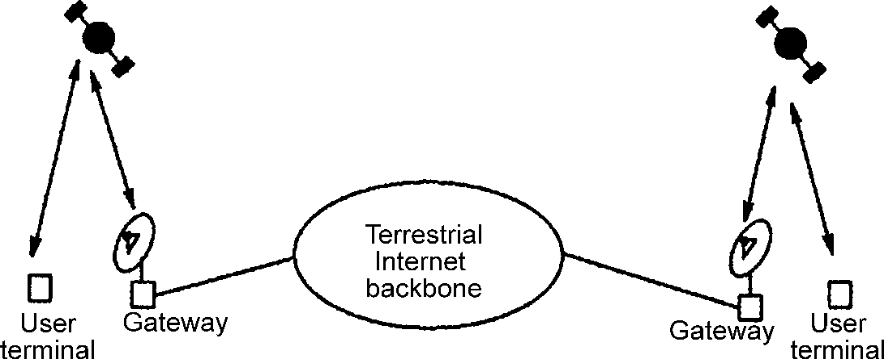

Figure :Satellite system for Internet access

Access/Core Network
A satellite-based access/core network has the architecture of Figure 7.15. In this scenario subscriber terminal data transmissions are again picked up by satellites. However, these are not necessarily sent to the gateway in order to reach their destination. In such an architecture, satellites have the ability to perform onboard processing and switching. This enables them to maintain ISLs which can be used to relay user transmissions to their destinations. Thus, for a satellite mobile receiver, packets can reach their destination either entirely through ISLs or through a combination of ISLs and the terrestrial Internet back- bone. For a ground-based destination station, the packet is forwarded to the gateway which relays it to the terrestrial Internet backbone. Thus, in this architecture the network formed among the satellites acts as a part of the Internet backbone. It is obvious that in this architecture satellites employ significant intelligence which is required for operating ISLs.

Asymmetric Access Architecture
In the two architectures mentioned above, terminal-satellite links are assumed to operate

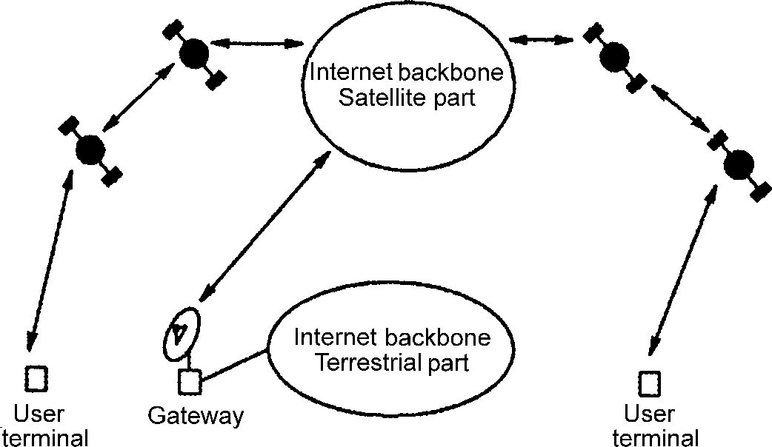

Figure : Satellite system acting as an Internet access and core network
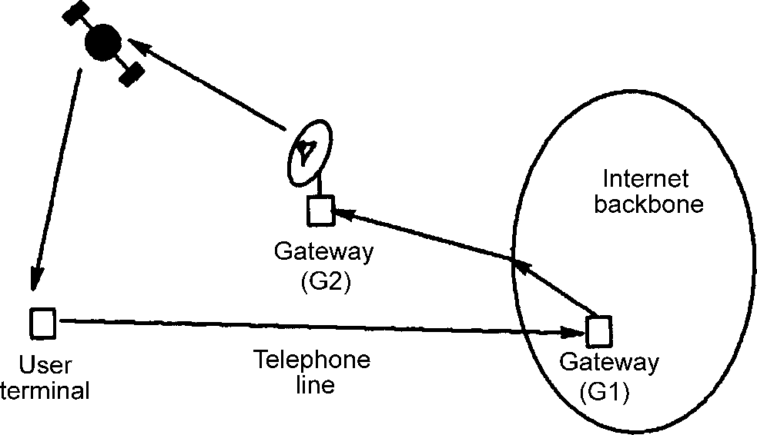

Figure: Internet access through a hybrid system

in both directions. However, terminal to satellite transmissions raises the complexity and thus the cost of the terminal. Thus, in an effort to make satellite-based Internet access more appealing to the consumer, the terminal to satellite links can be substituted by a low-rate terrestrial link, such a telephone link. The low rate of the terrestrial link is not a problem, since Internet traffic is highly asymmetric, with most of the traffic concerning data coming from an Internet server to the user, while the reverse link needs only to relay mouse clicks and user commands. Such an architecture can be considered a hybrid system.
The idea mentioned above is depicted in Figure 7.16. Users send their commands (such as requests for web pages) through the low-rate telephone line. This line is connected to the ISP’s gateway (G1), which examines the request and sends the corresponding data to the user through the satellite network. A system following this architecture is DirecPC.

Routing Issues
Routing is a challenging task in all wireless systems due to their inherent mobility. The same holds for satellite-based systems, especially LEO-based systems employing ISLs. In such systems, the main technical issue is dynamic topology. This is due to the rapid movement of LEO satellites which remain visible only for a small amount of time from a specific point on the Earth’s surface. In such a system, careful planning of the satellite constellation is needed, as there must always be at least one satellite within LOS of a specific user.
The rapid movement of the constellation continuously drops inter-plane ISLs and creates new ones in their place. On the other hand, inter-plane ISLs are maintained permanently. Thus, routing schemes should be able to handle such topology changes. Although these changes occur frequently, the good thing is that the strict movement of satellites into certain orbits makes these changes periodic and thus predictable. Two routing schemes that are considered as good candidates for routing in a satellite commu- nication system are Discrete Time Dynamic Virtual Topology Routing (DT-DVTR) and Virtual Node-based (VN) schemes [9]. These are briefly described below along with a discussion regarding routing in the asymmetric architecture described in Section 7.5.
DT-DVTR
This scheme works by acknowledging the periodic nature of the satellite constellation’s movement. The rotation period of the constellation is divided into a number of segments with each segment being identified by a single topology change, which takes place at its start. Thus, in each segment the routing problem is treated as a static routing problem and can be easily solved. Furthermore, the periodicity in constellation movement makes it possible to store predetermined solutions for the static routing problems and avoid costly computations.

TCP Enhancements
Satellite-based Internet will continue to serve applications using the conventional TCP/IP protocol stack. However, the performance of both these protocols is greatly affected by the characteristics of satellite links. In this section, we briefly describe these character- istics along with some techniques to enhance the performance of TCP over such links.

Fixed Wireless Access Systems

Wireless Local Loop versus Wired Access
Fixed Wireless Access (FWA) systems, which can also be called Wireless Local Loop (WLL) systems, are intended to provide primary access to the telephone network; that is, wireless services supporting subscribers in fixed and known locations. In general, WLL is a system that connects subscribers to the public switched telephone network (PSTN) using radio signals as a substitute for copper transmission media for all or part of the connection between the subscriber and the switch. This may include cordless access systems, proprietary fixed radio access, and fixed cellular systems. There are two alternatives to WLL: narrowband and broadband schemes. Narrowband WLL offers a replacement for existing telephone system while broadband WLL can provide high speed voice and data service. Some authors call WLL, Radio In The Loop (RITL), Fixed-Radio Access (FRA), or Fixed Wireless Access (FWA)
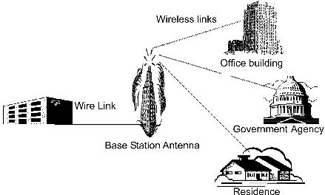

Figure : A wireless local loop configuration

WLL systems have a number of advantages over wired systems to subscriber local loop support. Among these are :
Time of installation. The time required to install a WLL system is much less than that for a wired system. The major issues are having a permission to use a given frequency band and finding an elevated site for the base station antenna. Once these issues are resolved, a WLL system can be installed very quickly.
†
Cost. Despite the fact that the electronics of a wireless transceiver is more expensive that for a wired system, overall total cost of wireless system components, installation, and maintenance is less than for a wired system.
†
Scale of installation. In WLL, radio transceivers are installed only for those subscribers who need the service at a given time. In wired systems, a cable is usually laid out in anticipation to serve an entire block or area.
†
The communications regulatory commissions in most countries have set aside frequency bands for use in commercial fixed wireless service. For example, the Federal Communica- tions Commission (FCC) in the United States has set aside fifteen frequency bands for use in this application.
Many WLL systems are based on Personal Communication Systems (PCS) or cellular technology. These PCS or cellular technologies can be analog such as AMPS, TACS, and ETACS, or digital such as GSM, DECT, PDC, CDMA, W-CDMA, and CDMA2000. WLL
systems based on such technologies can benefit from the associated economies of scale as well as the reduced costs. There are specific characteristics of fixed wireless systems that are not fully addressed by mobile wireless technologies without explicit consideration. While mobile technologies can readily be used for WLL systems, the ideal WLL system for a given market will be designed and adapted for fixed rather than mobile services. The major distinc- tions between mobile and fixed technologies are very clear from the WLL network deploy- ment, the WLL subscriber terminals, and the WLL interface to the PSTN.
Due to the fact that the subscriber locations in a WLL system are fixed and not mobile, the initial deployment of radio base stations need only provide coverage to areas where immedi-
ate demand for service is apparent. Service for a town or city, for example, can begin area by area as the WLL base stations are deployed. This distinction between mobile and fixed applications does not in itself imply much difference in the technology, but other dissimila- rities associated with network deployment do. It is important to note that the capacity needed for a WLL system is different from that for a fixed WLL system. A mobile system’s base stations must provide adequate capacity to support worst-case traffic, while a fixed system’s base stations must only provide the capacity needed to support a known number of subscri- bers.
In a fixed subscriber environment, a terminal is oriented for the greatest signal strength upon installation, and, if needed, a directional antenna pointing to the nearest WLL base station can be used to improve the signal quality in terms of the carrier-to-interference ratio or range extension. Furthermore, a fixed subscriber terminal will not experience the same magnitude of fading effects seen by a mobile terminal.
Due to the differences between fixed and mobile propagation environments, the transmit power levels of a fixed WLL system can be reduced compared to that of a mobile system, assuming the same range of coverage and all other variables hold constant. Directional antennas may be used at the base station to further improve the system’s link margins if the fixed subscribers are localized

Wireless Local Loop
In this section, we look at the main characteristics of the two well-known types of wireless local loop techniques: the Multichannel Multipoint Distribution Service (MMDS), and the Local Multipoint Distribution Service (LMDS).

Multichannel Multipoint Distribution Service (MMDS)
In the United States, the FCC has allocated five frequency bands in the range of 2.15–2.68 GHz for fixed wireless access using the Multichannel Multipoint Distribution Service (MMDS). Table 8.1 shows the fixed wireless communication bands that have been allocated by FCC.
The first two bands were licensed in the 1970s for TV broadcasting and they were then called Multipoint Distribution Services (MDSs). In 1996, the FCC increased the allocation and allowed for Multichannel Multipoint Distribution Services (MMDS). This new service has become a strong competitor to cable TV providers for offering services in rural and
Table :Frequency bands allocated by the United States FCC for fixed wireless communications bands

Frequency range (in GHz) Application

2.150–2.162 Licensed Multichannel Distribution Service (MDS), 2 bands of 6 MHz each
2.4000–2.4835 Unlicensed Industrial, Scientific, and Medical (ISM)
2.596–2.644 Licensed Multichannel Multipoint Distribution Service (MMDS),
8 bands of 6 MHz each
2.650–2.656 Licensed MMDS
2.6620–2.6680 Licensed MMDS
2.6740–2.6800 Licensed MMDS
5.7250–5.8750 Unlicensed National Information Infrastructure (ISM-UNII) 24.000–24.250 Unlicensed ISM
24.250–25.250 Licensed
27.500–28.350 Licensed LMDS/Block A
29.100–29.250 Licensed LMDS/Block A
31.000–31.075 Licensed LMDS/Block B
31.075–31.225 Licensed LMDS/Block A
31.225–31.300 Licensed LMDS/Block B
38.600–40.000 Licensed

remote areas that cannot be reached by broadcast or cable TV. It is due to this specific application that MMDS is also called wireless cable.
The FCC does not allow the transmitted power of the base station of an MMDS to service an area beyond 50 km. The subscriber antennas of the transmitter and receiver must be in the line of sight. The main advantages of MMDS, over the Local Multipoint Distribution Service (LMDS) are:
Due to the fact that equipment operating at lower frequencies is less expensive, the cost of the subscriber and base station is lowered.
†
Since the wavelengths of MMDS signals are larger than those for LMDS, MMDS signals can travel farther without suffering from power losses. This means that MMDS can operate in considerably larger cells, which lowers the cost of the electronics for base stations.
†
Because MMDS signals have relatively longer wavelengths, they are less susceptible to rain absorption. Moreover, MMDS signals do not get blocked easily by objects, which allow them to be sent for longer distances.
†

Local Multipoint Distribution Service (LMDS)
The Local Multipoint Distribution Service (LMDS) is the broadband wireless technology used to deliver voice, data, Internet, and video services in the 25 GHz and higher spectrum. It is considered a relatively new service. Due to the propagation characteristics of signals in this
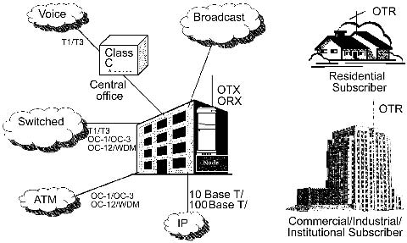

Figure An example of Local Multipoint Distribution Service (LMDS)

frequency range, LMDS systems use a cellular-like network configuration. In the United States, 1.3 MHz of bandwidth has been allocated for LMDS to deliver broadband services in point-to-point or point-to-multipoint configurations to residential and commercial customers; near 30 GHz. In Europe and most developing countries, frequencies near 40 GHz will be used for this purpose. Table 8.1 depicts the frequency bands that have been allocated by the FCC for fixed wireless access in the United States including LMDS. Figure 8.2 shows a general configuration on the Local Multipoint Distribution Service (LMDS).
In LMDS systems, the propagation characteristics of the signals limit the potential cover- age area to a single cell site. In metropolitan areas, the range of an LMDS transmitter can go up to 8 km. Signals are transmitted in a point-to-multipoint or broadcast method. The wireless return path, from subscriber to the base station, is a point-to-point transmission. It is impor- tant to note that the services offered through an LMDS network are entirely dependent on the operator’s choice of service.
The main advantages of LMDS systems are:
- It is easy and fast to deploy these systems with little disruption to the environment.
- As a result of being able to deploy these systems rapidly, realization of revenue is fast.
- LMDS are relatively less expensive, especially if compared with cable alternatives.
- Easy and cost-effective network maintenance, management, and operation.
- Data rate is relatively high, in the Mbps range.
- Scalable architecture with customer demand, which makes them cost effective.
It is expected that the LMDS services will be a combination of voice, video, and data. Therefore, both Asynchronous Transfer Mode (ATM) and Internet Protocol (IP) transport technologies will be practical when viewed within a country’s telecommunications infra- structure.
The major drawback of LMDS is the short range from the base station, which necessitates the use of a relatively large number of base stations in order to service a specific area .

Wireless Local Loop Subscriber Terminals (WLL)
A wireless local loop subscriber terminal can be a handset that allows good mobility. It also can be an integrated desktop phone and a radio set or may be a single or multiple line unit that can connect to a standard telephone. These terminals can be mounted outdoors or indoors with or without battery back-up depending on the need.
In a WLL system, subscribers receive phone service through terminals linked by radio to a network of base stations. As mentioned above, there are different types of terminal types. The difference between them reflects the use of different radio technologies in wireless local loop systems and the varying levels of services that can be supported.
Single and multiple line units that connect to standard wireline telephones are very well suited for fixed wireless services. Multiple line subscriber terminals provide more than one independent channel of service, where each line is routed as needed to support an office building, an apartment complex, or a group of payphones. By using such single and multiple line designs, the WLL subscriber terminal virtually becomes the analog of a wireline phone jack. WLL capabilities should be above and beyond those for many mobile systems. For example, the WLL and its subscriber terminal should support data and fax services as well as voice without requiring any special external digital modem adapters. Moreover, the subscri- ber terminals should support the signaling needed for payphone service.

Wireless Local Loop Interfaces to the PSTN
As mentioned earlier, subscribers to a wireless local loop (WLL) system are linked using radio to a network of radio base stations. The latter are tied by a backhaul network to allow connection to the Public Switched Telephone Network (PSTN). The WLL system’s interface to the telephone network can be supported through direct connection to the local exchange or by the use of its own switch. It is important to note that the way in which a WLL interconnects to the telephone network represents a key distinction between systems based on mobile wireless techniques or adapted to fixed wireless systems. The requirement to have mobile switch centers as part of wireless local loop systems means additional cost to the network operator. On the other hand, direct connection of a WLL system to existing central office switches effectively makes the wireless local loop system a direct extension of the wireline network. Moreover, it allows the use of switching resources that are underutilized.
It is possible to have the WLL system itself rely on the PSTN to provide all main switching functions. Moreover, it is desirable to have the WLL network adapted to fixed wireless services as a cost-effective extension of the wireline network. It should be possible to connect to existing local exchanges in a cost-effective manner that preserves the advanced features provided by the exchange.
The IEEE 802.16 Working Group on Broadband Wireless Access Standards develops stan- dards and makes recommendations to support the development and deployment of broadband Wireless Metropolitan Area Networks. The IEEE 802.16 is a unit of the IEEE 802 LAN/ MAN Standards Committee. This committee is working on developing interoperability stan- dards for fixed broadband wireless access. A similar standard called HIPERACCESS is being developed in Europe by the standardization committee for Broadband Radio Access Networks (BRAN). While the US LMDS bands are 27.5–28.35 GHz, 29.1–29.25 GHz, and 31.075–31.225 GHz, the European standard band is 40.5–43.5 GHz.
The Broadband Wireless Access (BWA) industry is following a similar path to that of IEEE 802.3, IEEE 802.11 through the IEEE Working Group on Broadband Wireless Access, which is developing the IEEE-802.16 wireless MAN standard for wireless metropolitan area networks. This standard, which covers licensed and license-exempt bands from 2 to 66 GHz worldwide, is creating a good foundation for the development of this industry. The Working Group 802.16 began its work in July 1999. This group currently has about 200 members and some observers from over 100 companies. The charter of the group is to develop standards that: (a) use licensed spectrum; (b) use wireless links with microwave or millimeter wave radios; (c) are capable of broadband transmission at a rate greater than 2 Mbps; (d) are metropolitan in scale; (e) provide public network service to fee-paying customers; (f) provide efficient transport of heterogeneous traffic supporting quality of service (QoS); and (g) use point-to-multipoint architecture with stationary rooftop or tower mounted antennas.
The IEEE 802.16 group’s work has primarily targeted the point-to-multipoint topology with a cellular deployment of base stations, each tied to core networks and in contact with fixed-wireless subscriber stations. Initial work has focused on businesses applications; small- to medium-size enterprises. However, attention has increasingly turned toward residential applications, especially as the lower frequencies have become available for two-way service.
Three subgroups have been established to produce standards for:
- IEEE 802.16.1. Air interface for 10–66 GHz.
- IEEE 802.16.2. Coexistence of broadband wireless access systems.

